1. Протестуй роботу сайту “[Київська міська лікарня ветеринарної медицини](https://www.kmlvm.com.ua/)” на мобільному пристрої.

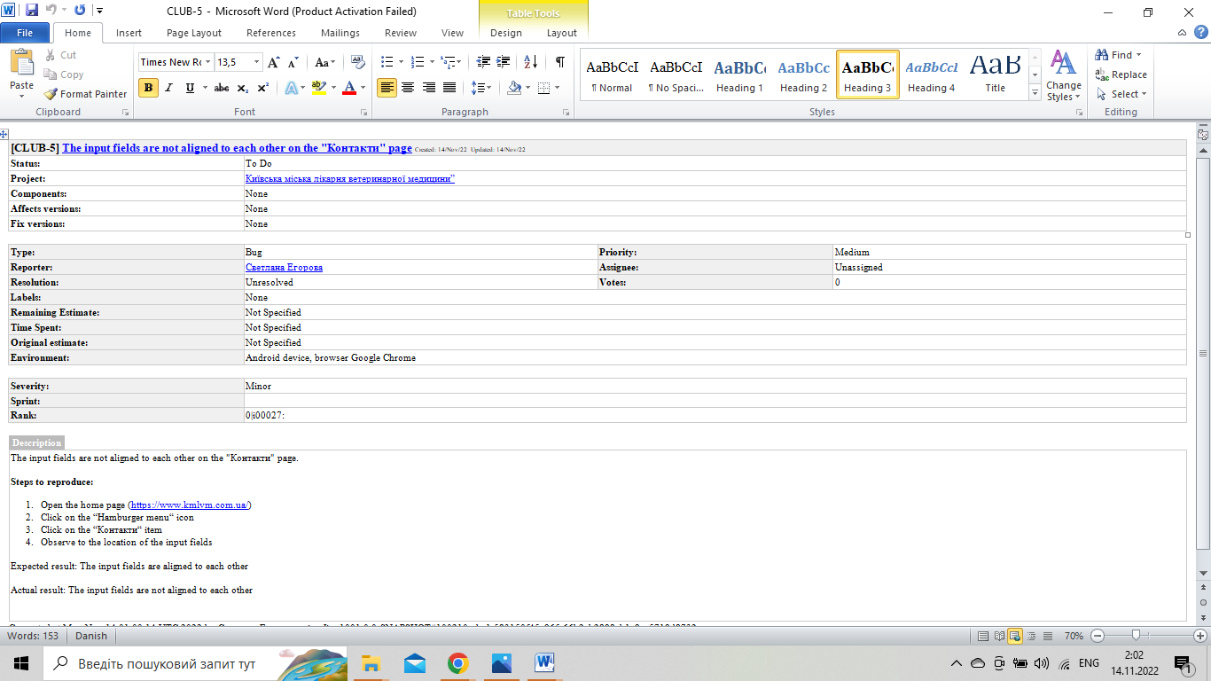

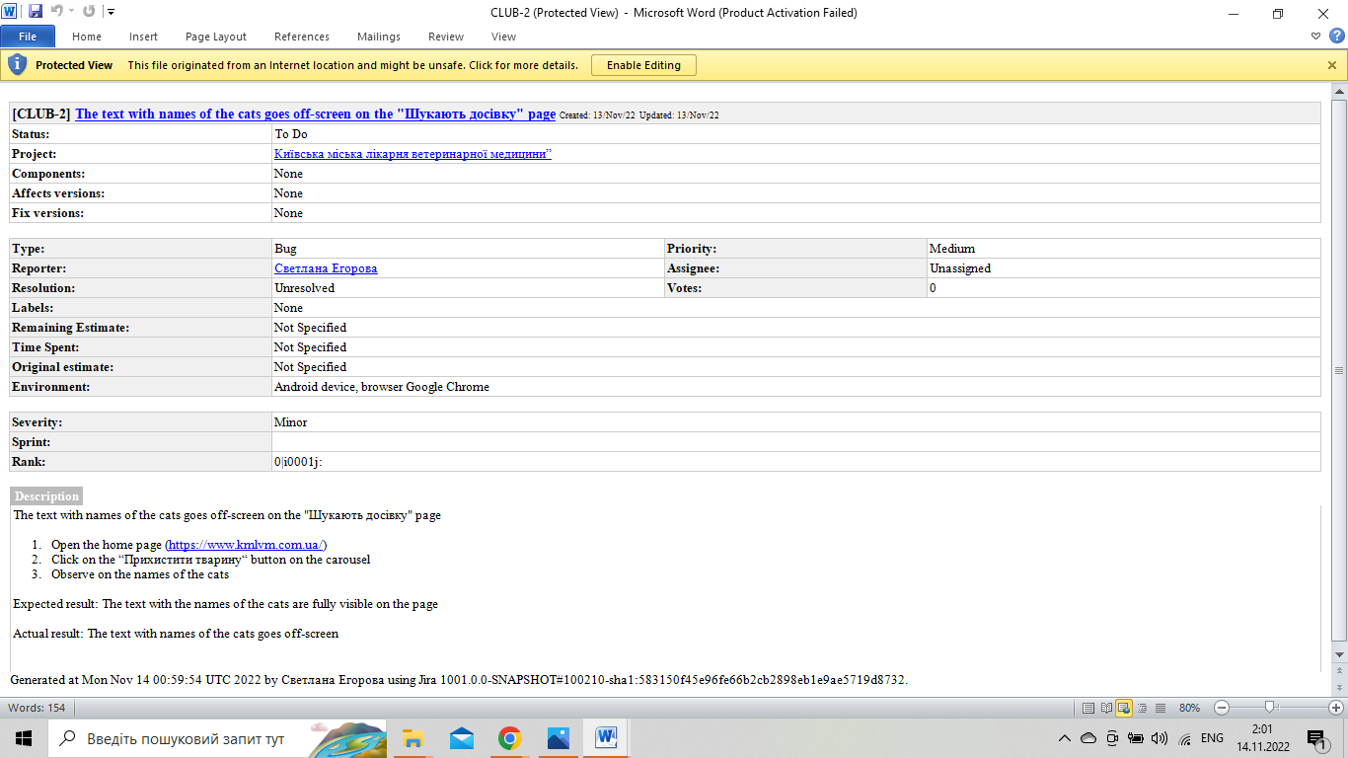

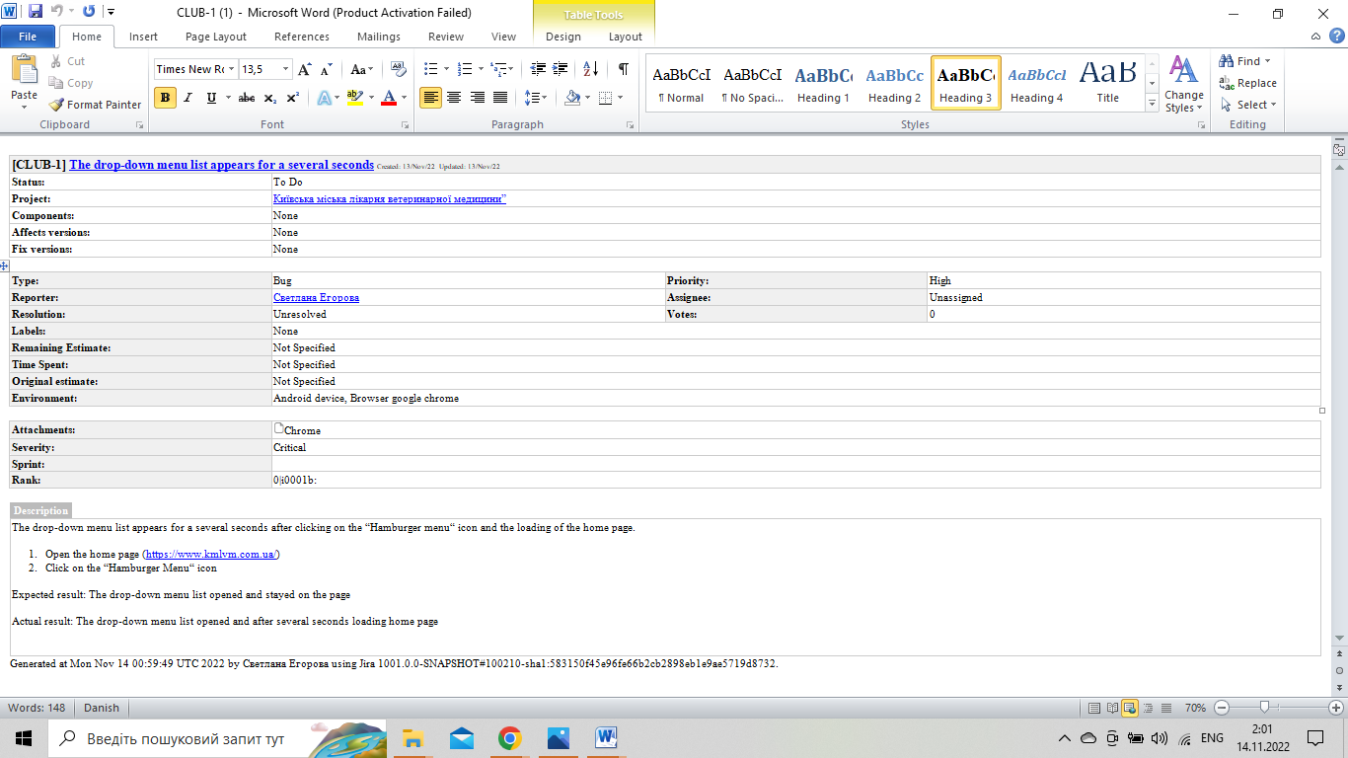

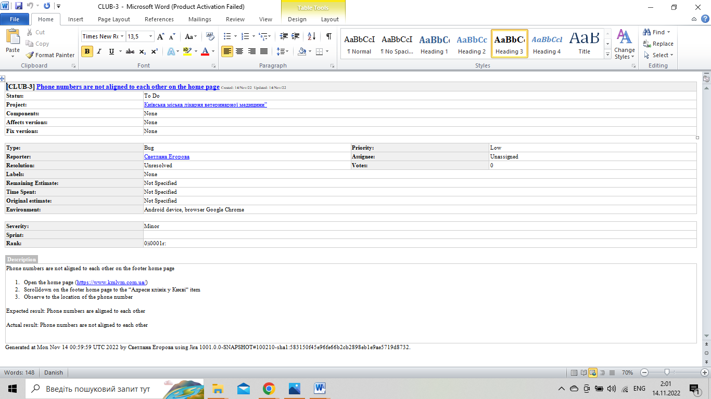

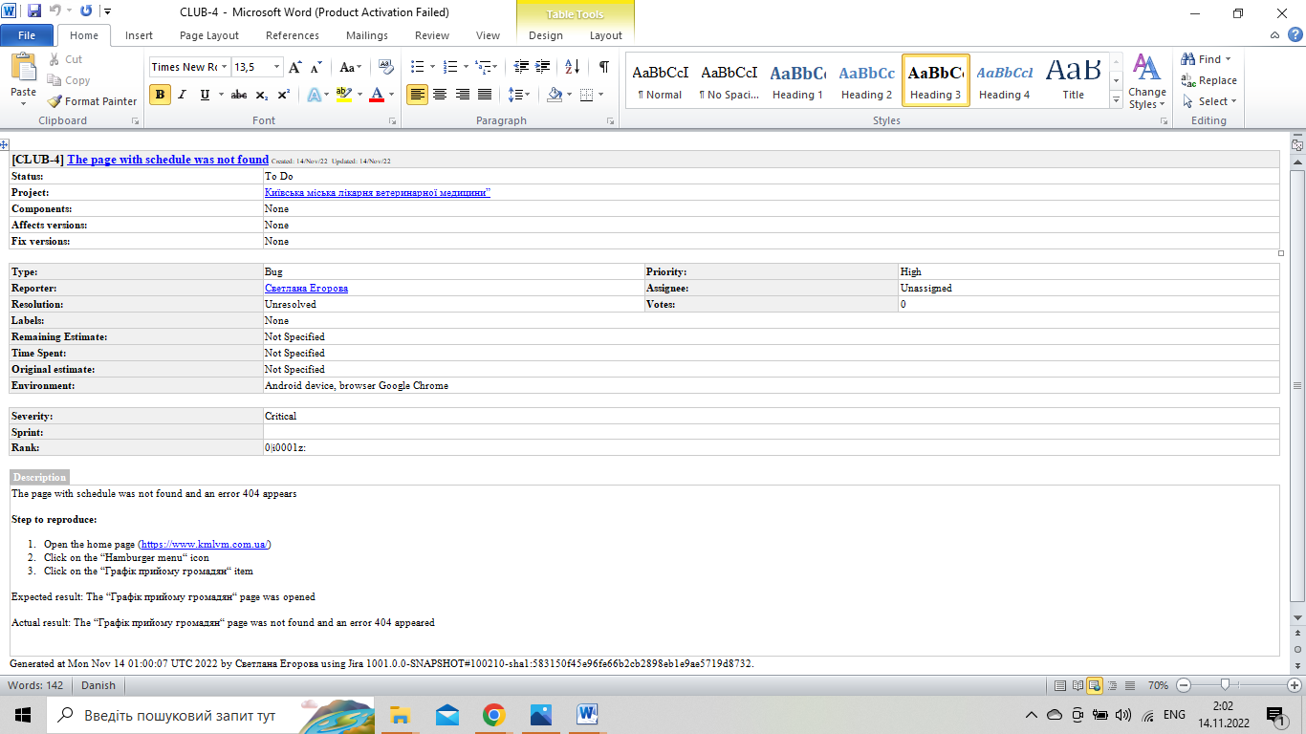

2. Checklist for the “Дія” add

1. Functional testing

1.1. New user registration:

* Authorization via Bank ID
* Authorization via Mono
* Authorization via “Пріват 24”
* Enter the correct password for authorization

1.2. Addiction new documents

1.3. Verification of documents that appeared in the application

1.4. Сheck that the scanner works correctly in documents

1.5. Checking the “Search” line

1. Usability testing

2.1. Check that the font of the text is easy to read

2.2. Checking the speed of loading documents

2.3. Check that the buttons are the right size and fit your thumbs

2.4. Checking the clear display of photos on documents

2.5. Сheck the name of the icon corresponded to its function

1. Compatibility testing

3.1. Check call acceptance when using the app

3.2. Check test mobile application in different OS

* iOS
* Android
* Windows

3.3. Сheck how the interface is displayed on different screens

3.4. Check on different processors

3.5. Checking on devices with different RAM

1. Performance testing

4.1. Check the response time of the application at startup

4.2. Check the performance of the application by running it for a long time under normal load.

4.3. Check the response time of the application to various requests

4.4. Checking the application on memory shortages

4.5. Increased volumes of data to be processed